H.T No
Regulations:
A17

Sreenidhi Institute of Science and Technology
(An Autonomous Institution)
Code No: 6Z214 Date: 19-June-2018 (FN)

MBA I-Year II-Semester External Examination, June - 2018 (Regular)
Quantitative Analysis for Business Decisions

Time: 3 Hours Max.Marks:75

Note: a) No additional answer sheets will be provided.
b) All sub-parts of a question must be answered at one place only, otherwise it will not be valued.
c) Missing data can be assumed suitably.

Part - A Max.Marks:25

Answer all QUESTIONS.

1. | Write the application of Operation research. | [3M]
2. | Write a structure of LPP. | [3M]
3. | List out the different steps in MODI method. | [3M]
4. | What is Decision tree? | [3M]
5. | Give an example of saddle point? | [3M]
6. | What is Queuing theory? | [2M]
7. | List out Application of areas of LPP. | [2M]
8. | Write a note on Travelling Salesman Problem (TSP). | [2M]
9. | What is Pure and mixed Strategy? | [2M]
10. | List out the different Queuing Model. | [2M]
Part – B Max.Marks:50
ANSWER ANY FIVE QUESTIONS. EACH QUESTION CARRIES 10 MARKS.

11. | a) | Explain different Models/ Techniques of operation Research | [5M]
 | b) | Write various steps in Operation research process. | [5M]
12. | a) | Solve the following LPP using the result of its dual problem  Min Z₁ = 24 x₁ + 30 x ₂  _{Subject to constraints}  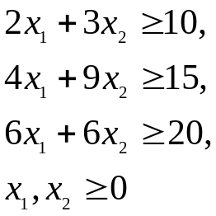 | [5M]
 | b) | Use simplex method to solve  Max Z = 3 x₁ + 2 x₂ + 5 x₃  _{Subject to constraints}  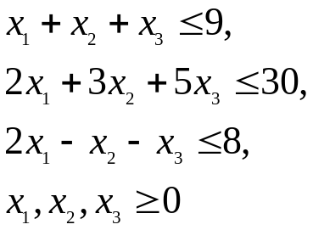 | [5M]
13. | a) | Solve the following transportation problem | [5M]
   | D₁ | D₂ | D₃ | D₄ | Supply
  O₁ | 1 | 2 | 3 | 4 | 6
  O₂ | 4 | 3 | 2 | 0 | 8
  O₃ | 0 | 2 | 2 | 1 | 10
  Demand | 4 | 6 | 8 | 6
 | b) | What is the unbalanced assignment problem? How is it solved by the Hungarian method? | [5M]
14. | a) | Explain the procedure of a decision tree. | [5M]
 | b) | A Finance Manager is considering a well. In the post, only 70% of wells drilled were successful at 20 meters depth in that area. Moreover, on finding no water at 20 meters, same persons in that area drilled it further up to 25 meters but only 20% of water was available at that level. The prevailing cost of drilling is 500 per meter. The Finance manager estimated that in case, if he does not get water in his own well: he will have to pay Rs.15,000 to pay water from outside for the same period of getting water from the well. The following decisions are considered.(i) Do not drill any well (ii)Drill up to 20 meters and(iii) If no water is found at 20 meters, drill further up to 25 meters. Draw an appropriate decision tree and determine the finance manager’s optimal strategy? | [5M]
15. | a) | Explain the algebraic method for solving 2×2 games by taking suitable examples. | [5M]
 | b) | Solve by using dominance property, the following game:  Player B  1 2 3  1  Player A 2 | [5M]
  6 | 8 | 6
  4 | 12 | 2
16. | a) | Identify and explain the basic characteristics of a queuing model. | [5M]
 | b) | If a period of 2 hours in a day (8-10 a.m) the trains arrive at the yard every 20 minutes but the service time continues to remain 36 minutes. Then calculate for this period.  (i) The probability that the yard is empty.  (ii) Find the Average queue length, on the assumption that the line capacity of the yard is limited to 4 only. | [5M]
17. | a) | A sales man has to visit five cities A, B, C, D and E. The distance (in hundred KMS) between the five cities as follows. | [5M]
   | A | B | C | D | E
  A | - | 8 | 7 | 9 | 6
  B | 8 | - | 7 | 6 | 7
  C | 7 | 9 | - | 10 | 6
  D | 5 | 6 | 10 | - | 9
  E | 6 | 7 | 8 | 10 | -
 | b) | Explain simplex method of solving linear programming problem. | [5M]

-- 00 -- 00 –

